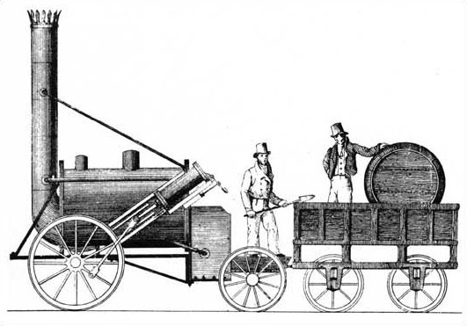

**Maths**

This term, we will start the year by mastering our place value skills to 10. We will learn about different ways to represent numbers as well as how to show comparisons of different values. We will also practise counting both forward and backwards which will help us identify one more and one less. We will then move on to look at addition and different addition facts.

**History**

In history, we will learn about the lives of significant others and the impact that they had on the world. We will learn about George Stephenson and what he created. We will then discuss how this would have changed Britain.

**Science**

In science, we will learn about the seasons and begin to observe seasonal changes. We will then move on to learning about the human body. We will learn to name different body parts and link them to different senses.

**RE**

In RE this half term, we will be exploring ‘what does it mean to belong to a faith/ community?’. We will look at what makes a community and roles and responsibilities people have within it.

**English**

In English this half term, we will be using our phonics skills to spell words accurately. We will also be practising using capital letters, full stops and finger spaces in our sentences.

We will be working towards retelling familiar stories and holding our sentences in our head. We will also be practising our handwriting and fine motor skills daily.

In reading we will be making predictions and discussing new vocabulary. We will continue to learn new sounds in our phonics sessions.

**How to get involved at home**

* Use Phonics Play Obb and Bob to read real and nonsense words.
* Say a number and then say one more and one less.
* Read your home reader weekly.
* Talk about changes you are seeing as the seasons change.

**Art/DT**

In art this half term, we will learn to mix colors and make tints. We learn about Wassily Kandinsky and create our own paintings inspired by his work.

**PHSE**

In PHSE this half-term, we will be learning about understanding our feelings and emotions with Miss Young.

**Music**

In music we will be learning how to keep a steady beat and follow simple rhythm patterns.

**PE**

In PE this half-term, we will be improving our hand eye coordination by focusing on different passes and catching.