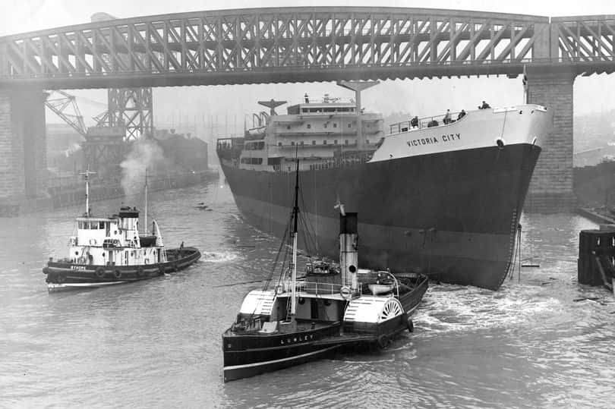

**Science**

In science this half term, we will learn that living things have changed over time and that fossils provide information about living things that inhabited the Earth millions of years ago. We will be given the opportunity to identify how animals and plants are adapted to suit their environment in different ways and that adaptation may lead to evolution.

**Maths**

In maths this half term, we will learn to read, write, order and compare numbers to 10,000,000. We will also use negative numbers and round whole numbers. We will use mental and written

methods for addition and subtraction to solve problems. We will also learn how to use BODMAS when carrying out calculations involving the four operations. Finally, we will compare, order and simplify fractions as well as adding, subtracting, multiplying and dividing them.

Alongside this, in our basic skills sessions, we will secure recall of multiplication and division facts as well as mental and formal written methods for the four operations. We will revisit prior learning in a daily basis in our Flashback 4 and Daily 5.

**PE**

In PE sessions this half term, we will continue to develop our tennis skills. We will focus on serving the ball accurately and developing our forehand and backhand techniques.

**RE**

In RE this half term, we will consider the story of

the ‘Creation’ and identify what type of text some Christians say Genesis 1 is, and its purpose.

**Spanish**

In Spanish this half term, we will learn how to name family members and will be able to ask someone how many brothers and sisters they have. We will learn how to introduce family members, including how old they are.

**History**

In history this half term, we will carry out a local study. We will learn about the significance of the shipbuilding industry in the North East.

**English**

In English this half term, we will write for a range of purposes and audiences. This will include writing an information text about the Windrush generation as well as writing ‘A diary of a Windrush kid’ in the first person.

In our reading sessions, we will be reading our class book ‘Coming to England’ by Floella Benjamin. We will continue to develop our fluency and develop our comprehension skills. In our dedicated grammar lessons, we will initially revisit and consolidate grammar from year 5 before learning about active and passive voice. We will continue to learn spelling rules and common exception words weekly (see spelling overview).

**PSHE**

In PSHE this half term, we will learn about feelings and emotions and healthy relationships and lifestyles.

**Art**

In art this half term, we will be studying the work of local artist Leigh Lambert. We will use his drawings and paintings as inspiration for our own.