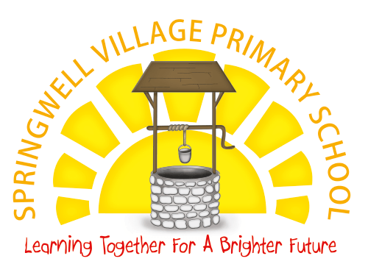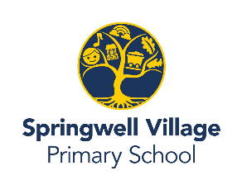

**Maths**

In maths this half term, we will begin looking at numbers within 100 and their place value. Children will have opportunities to practise counting forward and backward within 100 and partition two-digit numbers into tens and ones. As we progress through the half term, we will also recap counting in 2s, 5s and 10s and begin learning to count in 3s. Then we will focus on understanding fact families and identifying and recalling numbers to 100.

**Music**

In music this half term, we will be welcoming Mr Little to Year 2 as we begin to learn how to play the violin.

**Science**

In science this half term, we will be looking at everyday materials. The children will build a range of new vocabulary to describe materials and properties. We will also be conducting some experiments to help us understand why materials are used for certain purposes.

**PE**

In our PE sessions this half term, we will be developing our physical literacy as we engage in various games.

**History**

In history this half term, we will be learning about Grace Darling as we focus on learning about significant people in our locality. We will find out about how sea rescue has been improved since this event.

**PHSE**

This term, the children will be learning about feelings and emotions and how to manage their own emotions. They will also look at different types of behaviour and how they can affect others.

**English**

In English this half term, we will be focusing on two key stories - Grandad’s Island and The Tunnel. We will use our reading skills in order to predict, infer and learn new vocabulary. In addition to this, we will be focusing on using story maps to sequence events and retell parts of the story. We will also begin using adjectives to help us to describe characters and settings and explore and read reports.

During our phonics sessions we will be focusing on learning to spell using alternative sounds. The children will spend this half term revisiting sounds they learnt in year 1.

**How to get involved at home**

Encourage your child to practise their weekly spellings.

Continue to read with your child and your ask questions about what they have read in order to develop comprehension.

Count to and from 100 with your child including counting in 2s, 3s, 5s and 10s.

**Art**

This half term, we will be focusing on drawing and painting. We will look in detail at Vincent Van Gogh and try to recreate some of his artwork including Starry night. The children will practise skills such as mixing colours and adding detail through lines and dots.

**RE**

In RE this half term, we will be learning about Islam. We will look at what Muslims believe and start to understand some traditions and stories from the Quran.